Profile of the

Southern Illinois 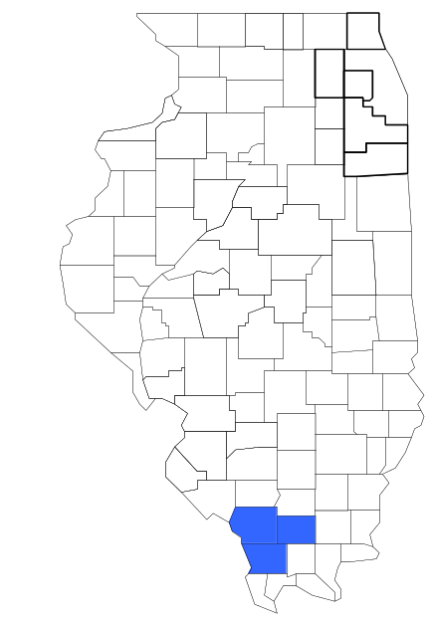Enforcement Group

Prepared by

The Research and Analysis Unit of the
Illinois Criminal Justice Information Authority

George H. Ryan, Governor
Peter B. Bensinger, Chairman
Candice M. Kane, Executive Director

March 2001



ILLINOIS
CRIMINAL JUSTICE
INFORMATION AUTHORITY

This project was supported by Grant # 99-DB-BX-0017, awarded to the Illinois Criminal Justice Information Authority by the Bureau of Justice Assistance, Office of Justice Programs, U.S. Department of Justice. The Assistant Attorney General, Office of Justice Programs, coordinates the activities of the following programs, offices and bureaus: Bureau of Justice Assistance, Bureau of Justice Statistics, National Institute of Justice, Office of Juvenile Justice and Delinquency Prevention, and the Office for Victims of Crime. Points of view or opinions contained within this document are those of the authors and do not necessarily represent the official position or policies of the U.S. Department of Justice.

Illinois Criminal Justice Information Authority
120 S. Riverside Plaza, Suite 1016
Chicago, Illinois 60606-3997
Telephone (312) 793-8550
Telefax (312) 793-8422
TDD: (312) 793-4170
World Wide Website http://www.icjia.state.il.us
ACKNOWLEDGMENTS

A number of organizations and individuals put a great deal of effort into the development of this document. The Authority’s Research and Analysis Unit is very grateful for the assistance provided by the following organizations:

Administrative Office of the Illinois Courts
Illinois Department of Human Services’ Office of Alcoholism and Substance Abuse
Illinois Department of Children and Family Services
Illinois Department of Corrections
Illinois State Police
Southern Illinois Enforcement Group
U.S. Bureau of the Census

In addition, the following individuals were instrumental in gathering, interpreting and presenting these data:

Sharyn Adams

Megan Alderden

Robert Bauer

Alissa Clark

John Condne

Karen Griffiths

Tracy Hahn

Jennifer Hiselman

David Katz

Joseph Kozenczak

Gary Kupsak

Erica Morrow

David Olson

Adrianna Perez

Gerard Ramker

Robert Taylor

CONTENTS

Section Page Number

EXECUTIVE SUMMARY

I. Introduction 1
II. Trends in Violent Index Offenses and Arrests 3
III. Trends in Drug Arrests 6
IV. Trends in Drug Seizures 15
V. Trends in Prosecutions for Drug Offenses 17
VI. Trends in Percent of Convicted Drug Offenders Sentenced to Prison 19
VII. Trends in Drug Treatment Admissions in SIEG Region by Drug Type 25
VIII. Trends in Drug Exposed Births 27
IX. Summary of Drug Situation 28
X. Appendices 30
Map 1 1999 Percent of Illinois' County-level Population Covered by an
Authority-funded Multi-jurisdictional Enforcement Group or Task Force 31
Map 2 1999 Illinois Cannabis Seizure Rates, by County 32
Map 3 1999 Illinois Controlled Substances Seizure Rates, by County 33
Map 4 1999 Illinois Methamphetamine Seizure Rates, by County 34
XI. Bibliography 35

LIST OF FIGURES

Figure Page Number

Figure 1. Violent Index Offense Rates for Participating and Non-participating Agencies in Region Covered by SIEG 3
Figure 2. 1999 Violent Index Offenses* Reported by Participating and Non-participating Agencies in Region Covered by SIEG 4
Figure 3. Violent Index Arrest Rates for Participating and Non-participating Agencies in Region Covered by SIEG 5
Figure 4. 1999 Violent Index Arrests* Reported by Participating and Non-participating Agencies in Region Covered by SIEG 5
Figure 5. Total Drug Arrest Rates for SIEG and Participating and Non-participating Agencies in Region Covered by SIEG 7
Figure 6. 1999 Drug Arrests* Reported by Participating and Non-participating Agencies in Region Covered by SIEG 8
Figure 7. Total 1999 Drug Arrests* Reported by Participating and Non-participating Agencies in Region Covered by SIEG, by Drug Type 8
Figure 8. Drug Arrests by SIEG 9
Figure 9. Percent of Total Drug Arrests Accounted for by SIEG 10
Figure 10. Cannabis Arrests Rates in the Region Covered by SIEG as Reported by Participating Agencies, Non-participating Agencies and SIEG 11
Figure 11. Percent of Cannabis Arrests Accounted for by SIEG
12
Figure 12. Controlled Substances Arrest Rates in the Region Covered by SIEG as Reported by Participating Agencies, Non-participating Agencies and SIEG 13
Figure 13. Percent of Controlled Substances Arrests Accounted for by SIEG 14
Figure 14. SIEG Drug Arrests for Possession versus Delivery, by Drug Type 14
Figure 15. Cannabis Seized and Submitted to ISP by Jackson, Union and Williamson Counties and Seized by SIEG 15
Figure 16. Powder and Crack Cocaine Seized and Submitted to ISP by Jackson, Union and Williamson Counties and Seized by SIEG 16
Figure 17. Number of Felony Filings in Jackson, Union and Williamson Counties 17
Figure 18. Total SIEG Drug Arrests and Percentage of Arrests Resulting in Prosecution 18
Figure 19. Sentences Imposed on Felons Convicted in Jackson, Union and Williamson Counties
19
Figure 20. Sentences Imposed on Convicted SIEG Drug Offenders 20
Figure 21. Number of Drug Offenders Committed to IDOC by SIEG and Region Covered by SIEG 21
Figure 22. Drug Offenders as a Percent of Total IDOC Commitments from Jackson, Union and Williamson Counties 22
Figure 23. Drug Offenders Committed to IDOC from Jackson, Union and Williamson Counties, by Offense Class 23
Figure 24. Substance Abuse Treatment Admissions from Jackson, Union and Williamson Counties 24
Figure 25. Comparison of Drug Arrests by SIEG and Participating and Non-participating Agencies vs. Drug Abuse Treatment Admissions in Jackson, Union and Williamson Counties, SFY 99 26
Figure 26. Cases of Drug-Exposed Infants in Jackson, Union and Williamson Counties 27
Figure 27. Availability of Drugs in Illinois, 1998 28
Figure 28. Price Per Gram in Illinois, 1998 29

EXECUTIVE SUMMARY

Since 1989, the Authority’s Research and Analysis Unit has received funds under the federal Anti-Drug Abuse Act of 1988 to document the extent and nature of drug and violent crime in Illinois and the criminal justice system’s response to these offenses. As a result of these efforts, the Authority has amassed a large amount of data measuring the extent and nature of drug and violent crime in Illinois and the impact these crimes have had on the criminal justice system. In addition, as part of its monitoring and evaluation efforts, the Authority also requires funded programs to submit monthly data reports describing their activities and accomplishments. This profile is intended to provide a general overview of the drug and violent crime problem in the jurisdictions covered by Illinois’ MEGs and task forces, and the response to these problems by the units.

Although the data presented in this report are by no means inclusive of all indicators, they do provide a general overview of drug and violent crime and the response and impact of the criminal justice system. The following represent general conclusions that can be made based on the data analyzed for this report.

- In 1999, nine local Illinois police agencies participated in SIEG (a participating agency is defined as one that contributes either personnel or financial resources to SIEG). Officers assigned to SIEG (totaling 25 in 1999, 11 from participating agencies) accounted for 6 percent of the total number of sworn police officers working for agencies participating in SIEG.

- The violent Index offense rate was collectively higher across jurisdictions participating in SIEG than among the combined jurisdictions that did not participate in SIEG (page 3).

- The drug arrest rate was collectively higher in those jurisdictions participating in SIEG than in those jurisdictions not participating in SIEG. The drug arrest rate achieved by SIEG was about half than that achieved across agencies participating in SIEG and similar to, but slightly higher than, the drug arrest rate achieved by those agencies not participating (page 6).

- When comparing the types of drug offenders arrested by those agencies participating in SIEG, those agencies not participating and SIEG, it was found that SIEG tended to target and arrest more serious drug law violators in 1999, specifically violators of the Controlled Substances Act, which tend to be felony-level offenses (page 9).

- The majority of all drug arrests reported by SIEG, for either violations of the Cannabis Control Act or the Controlled Substances Act, involve drug sale or delivery (page 14).

- Between 1993 and 1999, the amount of cannabis seized by SIEG decreased, while the amount of cocaine seized by SIEG increased dramatically (pages 15 and 16).

- Between 1989 and 1999, the majority of all drug arrests by SIEG resulted in prosecution. Of these SIEG drug offender prosecutions, 49 percent were for violations of Controlled Substances Act. In addition, between 1989 and 1999, nearly all drug offenders who were prosecuted as a result of SIEG activity were convicted (page 18).

- In 1999, among those SIEG drug offenders convicted and sentenced, probation sentences accounted for the largest proportion (79 percent), followed by prison sentences (21 percent). There were no drug offenders sentenced to jail in 1999 (page 20).

- Unlike the arrests made by the participating and non-participating agencies, the arrests made by SIEG tended to involve the substances considered to be most serious (i.e., felony versus misdemeanor) and the substances for which a large proportion of community residents were seeking and receiving substance abuse treatment in 1999 (page 25).

I. Introduction

The Southern Illinois Enforcement Group (SIEG) covers the Illinois counties of Jackson, Union and Williamson. Combined, these counties had a 1999 total population of 140,232 – 3 percent more than in 1990. In 1999, nine local Illinois police agencies participated in SIEG. These include the sheriff’s offices for Jackson, Union, and Williamson Counties and the following Carbondale, Herrin, Murphysboro, DeSoto, Marion, and Southern Illinois University. These agencies served 82 percent of the population in the three-county region covered by SIEG in 1999 (see Map 1 on page 31). A participating agency is defined as one that contributes either personnel or financial resources to SIEG.

In addition to agencies that participate in SIEG, these Illinois counties are served by 14 additional police departments that do not participate in SIEG. According to the Illinois State Police, county sheriffs and local police departments, in the three-county region covered by SIEG, combined, employed 205 full-time police officers as of Oct. 31, 1999, 175 of which worked for agencies participating in SIEG. In comparison, there were a total of just 25 officers assigned to SIEG in 1999, 11 of which were assigned by participating agencies, two from the Illinois State Police (ISP) and one forfeiture officer. Thus, the officers assigned to SIEG during 1999 accounted for a relatively small proportion—6 percent—of the total number of sworn police officers working in the participating police departments.

Since 1989, the Authority’s Research and Analysis Unit has received funds under the federal Anti-Drug Abuse Act of 1988 to document the extent and nature of drug and violent crime in Illinois and the criminal justice system’s response to these offenses. As a result of these efforts, the Authority has amassed a large amount of data measuring the extent and nature of drug and violent crime in Illinois and the impact these crimes have had on the criminal justice system. In addition, as part of its monitoring and evaluation efforts, the Authority also requires funded programs to submit monthly data reports describing their activities and accomplishments. To put this information into the hands of Metropolitan Enforcement Group (MEG) and Drug task force directors and policy board members, the Authority’s Research and Analysis Unit has developed profiles – of which this is one – for each MEG and task force. The profile is intended to provide a general overview of the drug and violent crime problem in the jurisdictions covered by Illinois’ MEGs and task forces, and the response to these problems by the units.

In addition to administering federal block-grant funds that come to Illinois for crime control initiatives, the Illinois Criminal Justice Information Authority is also responsible for providing policymakers, criminal justice professionals and others with information, tools and technology needed to make effective decisions that improve the quality of criminal justice in Illinois. The Authority provides an objective system-wide forum for identifying critical problems in criminal justice, developing coordinated and cost-effective strategies, and implementing and evaluating solutions to those problems. The specific powers and duties of the Authority are delineated in the Illinois Criminal Justice Information Act (Illinois Compiled Statutes, Ch. 20, Sec. 3930). Two of the Authority’s many responsibilities are serving as a clearinghouse of information and research on criminal justice and undertaking research studies to improve the administration of criminal justice.

While the data presented in this report are by no means inclusive of all indicators, they do provide a general overview of drug and violent crime and the response and impact of the criminal justice system. In addition, these data are readily available and consistently defined through existing statewide data collection mechanisms. Some data presented in this profile have been analyzed differently than in previous years; therefore, caution must be taken when comparing numbers presented with previous profiles.
While a considerable amount of the information presented in this profile has been provided to the Authority by SIEG, a number of state agencies have also provided data to the Authority that are included in this report. Specifically, the Illinois State Police, the Administrative Office of the Illinois Courts, the Illinois Department of Human Services’ Office of Alcoholism and Substance Abuse, the Illinois Department of Corrections and the Illinois Department of Children and Family Services all provided data used to develop this profile. The support and cooperation of these agencies and their staffs have helped make this report an informative and timely source of information on the activities of the criminal justice system in Illinois.

- Trends in Violent Index Offenses and Arrests

While most of Illinois’ Metropolitan Enforcement Groups and Drug task forces are primarily involved in drug enforcement activities, it is clear that the relationship between drugs and violence is particularly evident in a number of Illinois communities. In addition, a number of MEGs and task forces have increased their involvement in the investigation of violent crime, particularly that associated with gang activity and violence related to drug distribution, sale and turf battles. One of the most commonly used indicators of the level of crime in a particular jurisdiction is the number of Index offenses reported to the police. In Illinois, as part of the Illinois Uniform Crime Reporting (I-UCR) program, every law enforcement agency in the state is required to report crime data monthly to the Illinois State Police (ISP). There are eight separate offenses that constitute the Crime Index, including murder, criminal sexual assault, robbery, aggravated assault (violent Index offenses), burglary, theft, motor vehicle theft and arson (property Index offenses). Although these eight offenses do not account for all crimes reported to the police, they are considered to be the most serious, frequent, pervasive and consistently defined by different law enforcement agencies.

In 1999, the number of violent Index offenses reported to the police in the three-county region covered by SIEG totaled 532, a 15 percent decrease from the 627 offenses reported in 1993. The majority (69 percent) of violent Index offenses reported to the police between 1993 and 1999 were aggravated assaults, while 16 percent were criminal sexual assault.

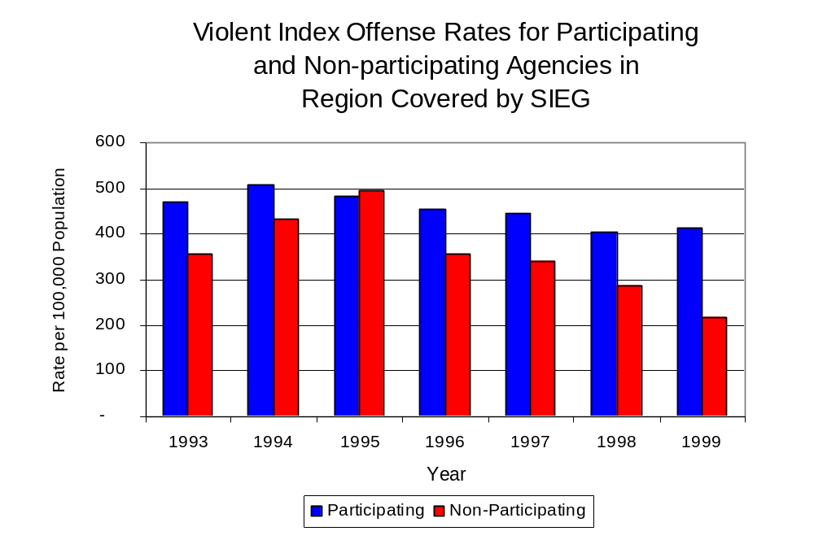
During the period analyzed, the violent Index offense rate for the region covered by SIEG decreased 16 percent, from 446 offenses per 100,000 population in 1993 to 375 offenses per 100,000 population in 1999. Similarly, the violent Index offense rate in the participating agencies decreased 12 percent, from 471 to 412 offenses per 100,000 population, while the rate in the non-participating agencies decreased 39 percent, from 356 to 218 offenses per 100,000 population (Figure 1). Thus, the violent Index offense rate was collectively higher across the jurisdictions that participated in SIEG than it was among the agencies that did not participate in SIEG.
Source: ICJIA calculations using
Illinois State Police and U.S. Census Bureau data
Figure 1

Across local law enforcement agencies covered by SIEG’s jurisdiction, the Carbondale Police Department accounted for one-third (33 percent) of all violent offenses reported to the police in 1999. Five additional departments: Murphysboro Police Department, Marion Police Department, Jackson County Sheriff’s Office, SIU-Carbondale Police Department and the Williamson County Sheriff’s Office accounted for an another 47 percent of violent offenses that same year (Figure 2). Agencies that reported fewer than ten violent offenses in 1999 and those agencies from smaller jurisdictions that report UCR data through another agency were excluded from Figure 2. When controlling for differences in the populations served by these law enforcement agencies, the violent Index offense rate ranged from 54 violent Index offenses per 100,000 population in Jonesboro to 1,517 offenses per 100,000 population in Grand Tower.

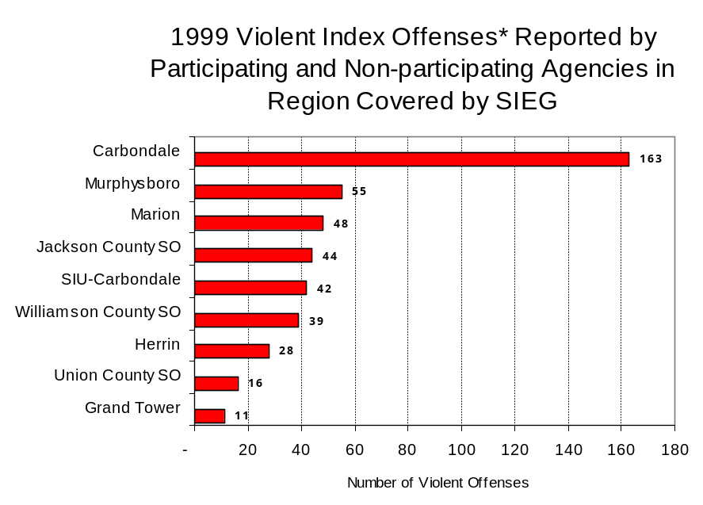
Source: Illinois State Police *Agencies reporting ten or more violent offenses
Figure 2

An indicator of the workload that law enforcement agencies place on other components of the justice system is the number of arrests made by police, including those for violent and property Index offenses and drug offenses. Unlike offenses, which are what police must respond to, arrests represent those offenders who may eventually be processed through other components of the justice system, including the courts, county jails, and state and local correctional programs.

Between 1993 and 1999, the number of arrests for violent Index offenses made by law enforcement agencies in the region covered by SIEG decreased slightly, from 330 to 327. The majority (89 percent) of violent Index arrests were for aggravated assaults, followed by robberies (6 percent).

During the period analyzed, the violent Index arrest rate for the region covered by SIEG decreased 2 percent, from 235 offenses per 100,000 population in 1993 to 231 arrests per 100,000 population in 1999. The violent Index arrest rate in the participating agencies increased 6 percent, from 234 to 248 offenses per 100,000 population, while the rate in the non-participating agencies decreased 37 percent, from 254 to 159 offenses per 100,000 population (Figure 3).

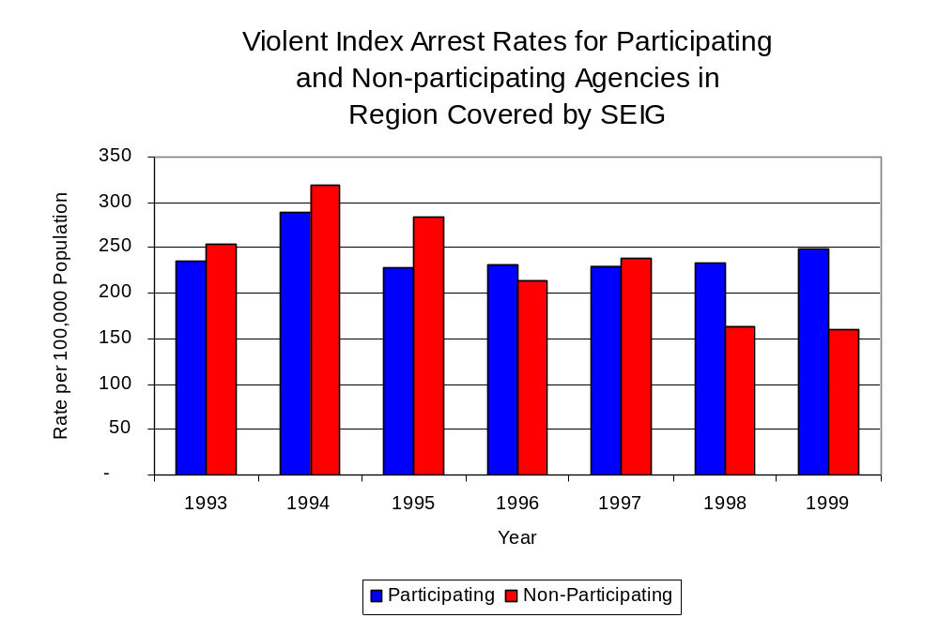
Figure 3
Source: ICJIA calculations using
Illinois State Police and U. S. Census Bureau data

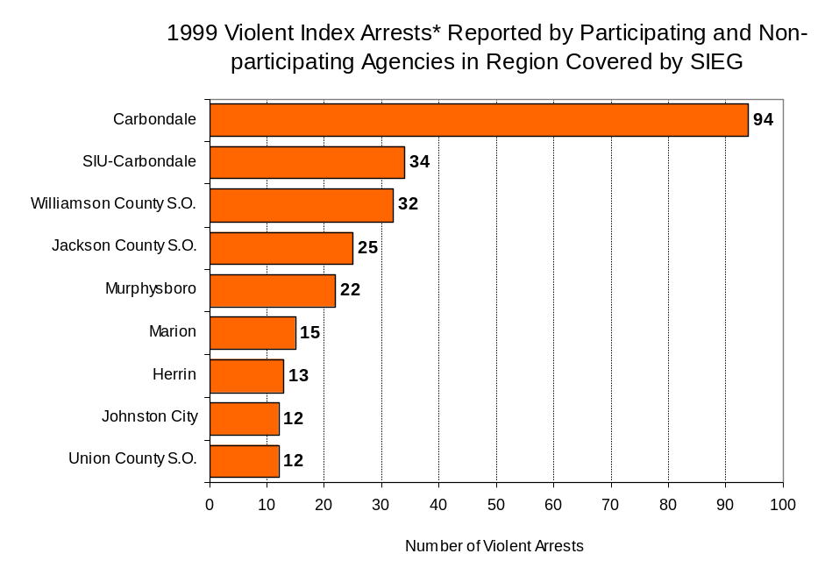
The majority (56 percent) of arrests for violent Index offenses occurring in the three-county region covered by SIEG were made by three agencies. Eight agencies had fewer than ten arrests for violent Index offenses reported in 1999 and are excluded from Figure 4. Of the 286 violent Index arrests made in 1999, the Carbondale Police Department accounted for the largest portion (33 percent), followed by the SIU-Carbondale Police Department (12 percent) and the Williamson County Sheriff’s Office (11 percent) (Figure 4).
Source: Illinois State Police* Agencies reporting ten or more violent Index arrests
Figure 4

III. Trends in Drug Arrests

There are two sources of drug arrest data presented in this section. One source is the Illinois Uniform Crime Reporting (I-UCR) program that includes information submitted by local law enforcement agencies on the number of persons arrested for violations of Illinois’ Cannabis Control Act, Controlled Substances Act, Hypodermic Syringes and Needles Act, and Drug Paraphernalia Control Act. In addition, data on drug arrests made by Illinois’ MEGs and task forces are reported to the Illinois Criminal Justice Information Authority. In some jurisdictions, arrests made by the MEG or task force may be reported by both local law enforcement agencies through the I-UCR and to the Authority by the unit. In other jurisdictions, arrests made by the MEG or task force are only reported to the Authority by the unit. Therefore, in some instances drug arrests may be double counted – included in both local agency statistics reported to I-UCR and those of the MEG or task force. Currently there is no mechanism in place to ensure that drug arrest statistics are not being duplicated at both the local agency and MEG/task force level. This should be kept in mind when interpreting the information presented in the following section.

The majority of drug offenses in Illinois are violations of either the Cannabis Control Act – which prohibits the possession, sale and cultivation of marijuana – or the Controlled Substances Act – which prohibits the possession, sale, distribution or manufacture of all other illegal drugs, such as cocaine and opiates. Illinois also has various other laws prohibiting other drug-related activity. These include the Hypodermic Syringes and Needles Act – which prohibits the possession or sale of hypodermic instruments – and the Drug Paraphernalia Control Act – which prohibits the possession, sale or delivery of drug paraphernalia. In general, violations of Illinois Controlled Substances Act are considered to be more serious, since they primarily involve cocaine, heroin, methamphetamine, and hallucinogens, and are almost all classified under Illinois law as felonies. The majority of cannabis and drug paraphernalia offenses encountered by police, on the other hand, tend to be misdemeanor-level offenses.

In 1999, local law enforcement agencies in the counties covered by SIEG reported 402 arrests for drug law violations, an 87 percent increase from 1993 (215 arrests). Between 1993 and 1999, arrests for violations of Illinois’ Cannabis Control Act consistently out-numbered arrests for violations of the Controlled Substances Act in Jackson, Union and Williamson counties, combined. During the same period, the number of arrests for violations of the Cannabis Control Act in these three counties combined increased 41 percent, from 150 to 212. Arrests for violations of the Controlled Substances Act in the three counties combined increased only slightly from 54 to 57. In addition, arrests for violations of the Drug Paraphernalia Control Act, enacted in 1993, increased from nine in 1993 to 130 in 1999. Much of this increase can be attributed to a 1994 addition to the Drug Paraphernalia Control Act, which included the possession of drug paraphernalia as a violation.

Because arrests for violations of the Drug Paraphernalia Control Act are frequently made in conjunction with other drug offense arrests, these arrests may be double-counted, thus skewing the actual number of drug arrests. Therefore, only arrests for violations of the Cannabis Control Act and Controlled Substances Act will be used for drug arrest comparisons between SIEG and the participating and non-participating agencies.

The drug arrest rate for the Cannabis Control and Controlled Substances Acts combined, in the region covered by SIEG, increased 31 percent between 1993 and 1999, from 145 arrests per 100,000 population in 1993 to 190 arrests per 100,000 population in 1999. Similarly, the drug arrest rate in the participating agencies increased 32 percent, from 160 to 211, and the drug arrest rate for non-participating agencies increased 14 percent, from 85 to 97 arrests per 100,000 population. The drug arrest rate for SIEG nearly doubled between 1993 and 1999, from 56 to 107 arrests per 100,000 population (Figure 5). Thus, the drug arrest rate tended to be higher collectively in the jurisdictions that participated in SIEG than in those jurisdictions that did not participate in SIEG. The drug arrest rate achieved by SIEG was lower than that achieved in those jurisdictions participating in SIEG and similar to, but slightly higher than, the drug arrest rate for non-participating agencies, meaning that SIEG made almost as many arrests as non-participating agencies for violations of the Cannabis and Controlled Substances Acts with only 14 officers.

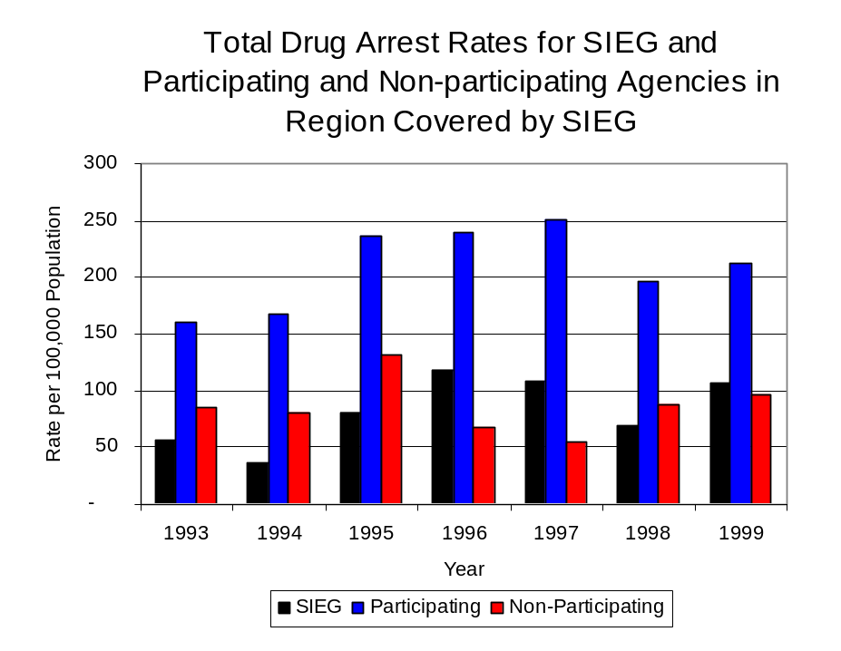
Source: ICJIA calculations using Illinois State
Police, SIEG and U.S. Census Bureau data
Figure 5

Across the individual local law enforcement agencies in the region covered by SIEG, the total number of drug arrests ranged from one to 165. Of the 398 drug arrests made during 1999 in the three-county region, two agencies accounted for the majority (62 percent). Nine agencies had fewer than ten drug arrests reported in 1999 and are excluded from Figure 6. Carbondale Police Department accounted for the largest portion of drug arrests at 41 percent, followed by the SIU-Carbondale Police Department accounting for an additional 20 percent. (Figure 6). With the exception of Carterville, all of the agencies listed in Figure 6 participated in SIEG.

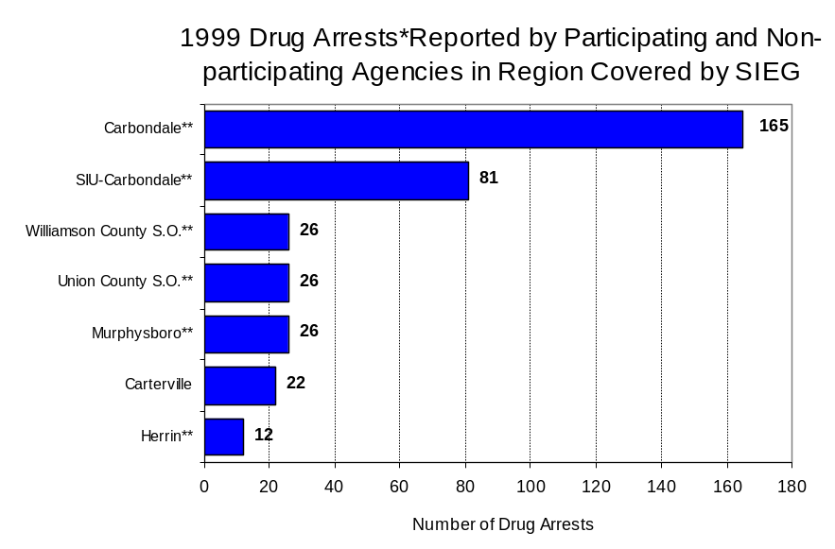
When 1999 drug arrests were compared across local law enforcement agencies within the three-county region covered by SIEG, similar patterns were noted in the distribution of arrests by drug type. In 1999, violations of the Cannabis Control Act accounted for the largest portion of drug arrests by all local agencies that reported at least ten drug arrests. Arrests for violations of either the Drug Paraphernalia Control Act or the Controlled Substances Act accounted for the second largest portion of arrests across individual agencies in the region. In fact, arrests for either of these violations comprised equal portions of arrests among those made by the Murphysboro and Herrin Police Departments. Only two local agencies reported any arrests for violations of the Hypodermic Syringes and Needles Act (Figure 7).
Figure 6
Source: Illinois State Police *Agencies reporting ten or more drug arrests
**Agencies participating in SIEG
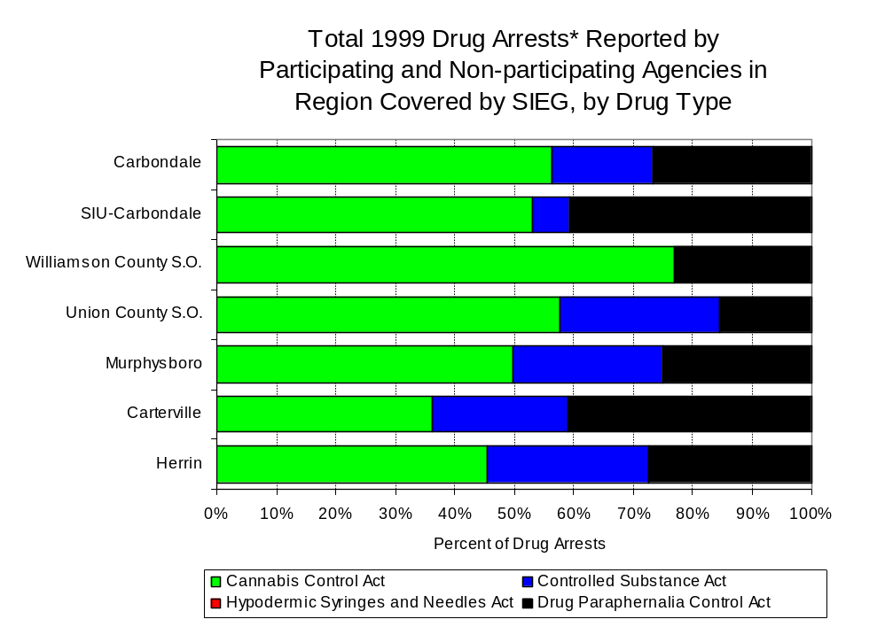
Figure 7
Source: Illinois State Police* Agencies reporting ten or more drug arrests

Between 1993 and 1999, the number of combined cannabis and controlled substances arrests made by SIEG nearly doubled, from 65 to 124 (Figure 8). Similar to drug arrests made by most local police departments in the region, violations of the Cannabis Control Act accounted for the majority of drug arrests made by SIEG throughout most of the period analyzed. Despite this, the number of SIEG arrests for violations of the Controlled Substances Act increased from six to 74, while arrests for violations of the Cannabis Control Act decreased from 59 to 50 (Figure 8).

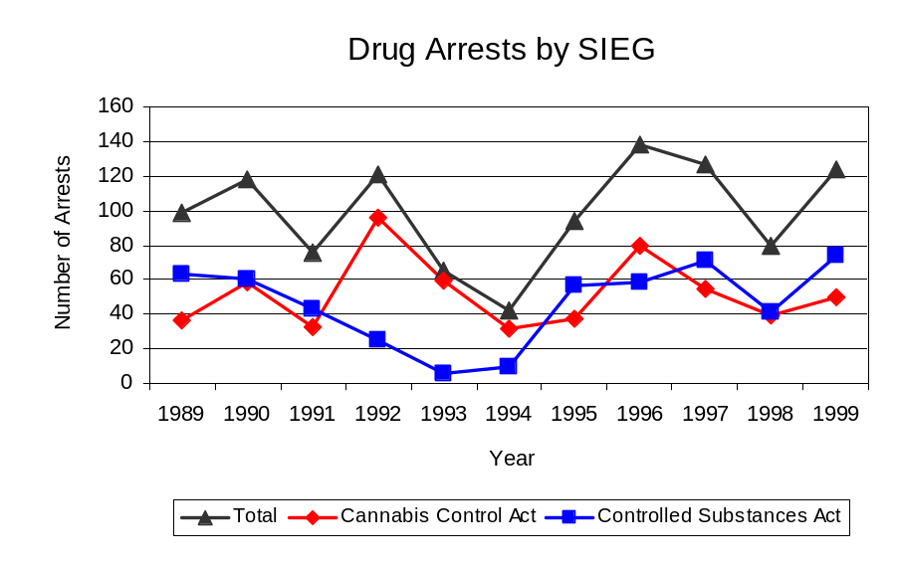
Between 1993 and 1999, the proportion of drug arrests accounted for by violations of the Controlled Substances Act decreased somewhat for participating agencies and increased for non-participating agencies. For SIEG, the proportion of drug arrests accounted for by controlled substance violations increased substantially, from 9 percent in 1993 to 60 percent in 1999. For the participating agencies, arrests for violations Controlled Substance Act accounted for 21 percent of the drug arrests in 1999, compared to 28 percent in 1993; whereas the proportion of controlled substances arrests increased from 10 percent to 22 percent of arrests made by non-participating agencies during the same period. Thus, the arrests by SIEG were more likely than arrests by either participating or non-participating agencies to involved violations of the Illinois’ Controlled Substances Act, as opposed to the Cannabis Control Act. One interpretation of this pattern is that SIEG is more focused in who they are targeting and arresting than local departments, and are also getting a more serious drug law violator, since violations of the Controlled Substances Act are more likely to involve felony-level offense.
Source: SIEG
Figure 8

The data presented below represent the percent of total drug arrests made by participating agencies that were accounted for by SIEG. An upper and lower bound is shown in Figure 9, which accounts for whether or not the units numbers are counted as part of the UCR submissions made by participating departments (which is unknown at this point). The upper bound indicates the percentage of arrests if all of the SIEG arrests are included in the local UCR submissions. The lower bound indicates the percentage if none of the SIEG arrests are included in the local UCR submissions.

It is estimated that the proportion of all drug arrests made in the jurisdictions of participating agencies, and accounted for by SIEG, was between 27 to 36 percent in 1993, increasing to between 34 to 51 percent in 1999. Thus, despite the fact that the officers assigned to SIEG accounted for a small proportion of the total number of officers in participating agencies, they accounted for a relatively large proportion of the drug arrests made in the jurisdiction of the participating agencies in most of the years analyzed.
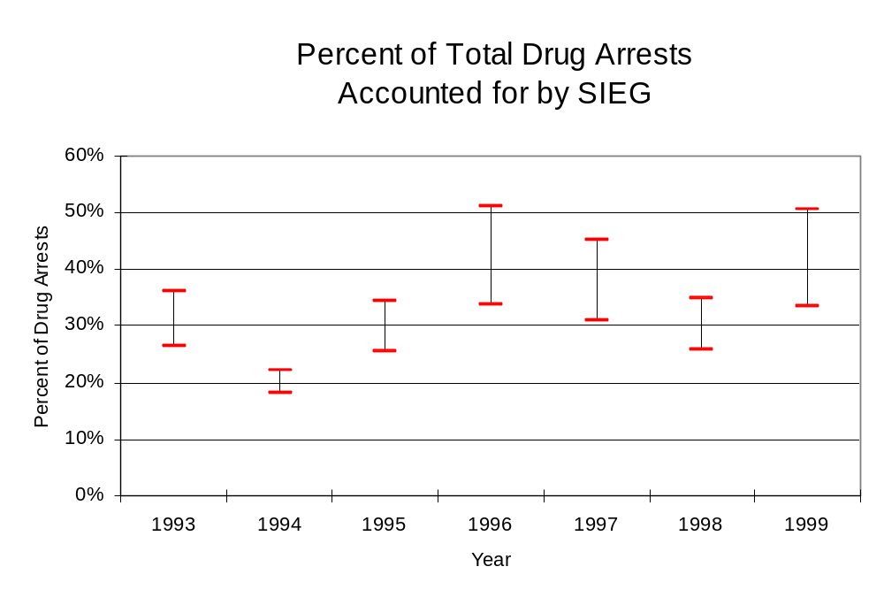
Figure 9
Source: ICJIA calculations using
Illinois State Police and SIEG data

The number of arrests for violations of Illinois’ Cannabis Control Act in Jackson, Union and Williamson counties totaled 211 in 1999, 44 percent more than the 147 arrests made for cannabis violations in 1993. Between 1993 and 1999, the proportion of all drug arrests accounted for by violations of the Cannabis Control Act in the three-county region increased from 74 percent to 79 percent. Agencies participating in SIEG accounted for the majority (91 percent) of the total number of arrests for cannabis violations. SIEG reported a total of 50 arrests for cannabis violations in 1999, 40 percent of the unit's drug arrests.

During the period analyzed, the cannabis arrest rate for the region covered by SIEG increased 42 percent, from 105 arrests per 100,000 population in 1993 to 149 arrests per 100,000 population in 1999. The cannabis arrest rate in the participating agencies increased 48 percent, from 112 to 166 arrests per 100,000 population. The arrest rate in the non-participating agencies remained unchanged at 76 arrests per 100,000 population, while the cannabis arrest rate for SIEG decreased 16 percent, from 51 to 43 arrests per 100,000 population) (Figure 10).

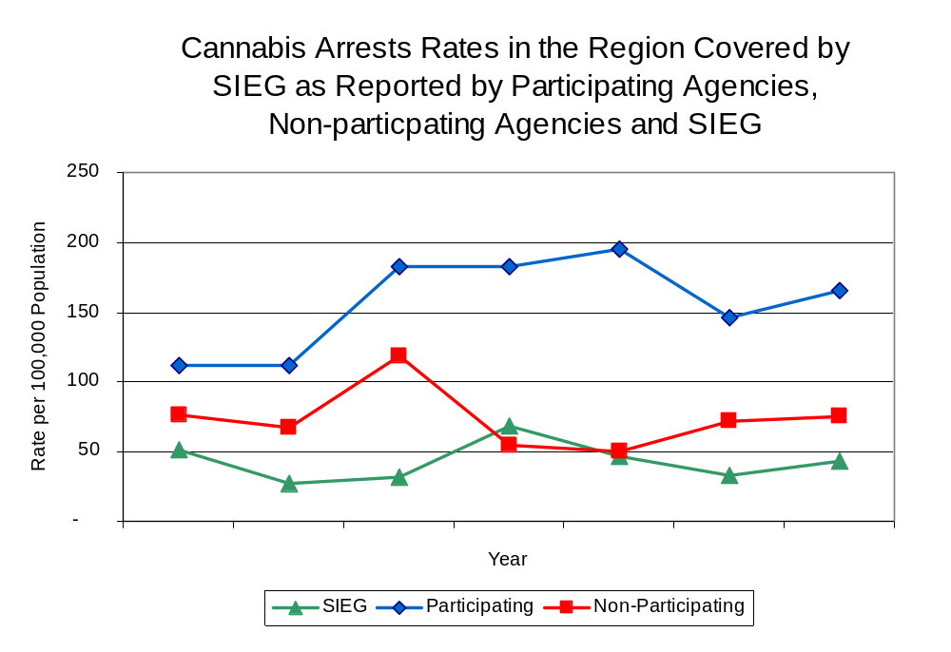
Source: ICJIA calculations using
Illinois State Police and SIEG data
Figure 10
The data presented below represent the percent of total arrests for the violation of the Cannabis Control Act made by participating agencies that was accounted for by SIEG. An upper and lower bound is shown in Figure 11, which accounts for whether or not the units numbers are counted as part of the UCR submissions made by participating departments (which is unknown at this point). The upper bound indicates the percentage of arrests if all of the SIEG arrests are included in the local UCR submissions. The lower bound indicates the percentage if none of the SIEG arrests are included in the local UCR submissions.

It is estimated that the proportion of all arrests for the violation of the Cannabis Control Act made in the jurisdictions of participating agencies, and accounted for by SIEG, was between 31 to 46 percent in 1993, but decreased to between 21 to 26 percent in 1999. The data presented in Figure 11 suggest that although arrests for the violation of the Cannabis Control Act made by SIEG in 1993 represented a large proportion of such arrests made in the jurisdictions of participating agencies, this proportion dropped in subsequent years.

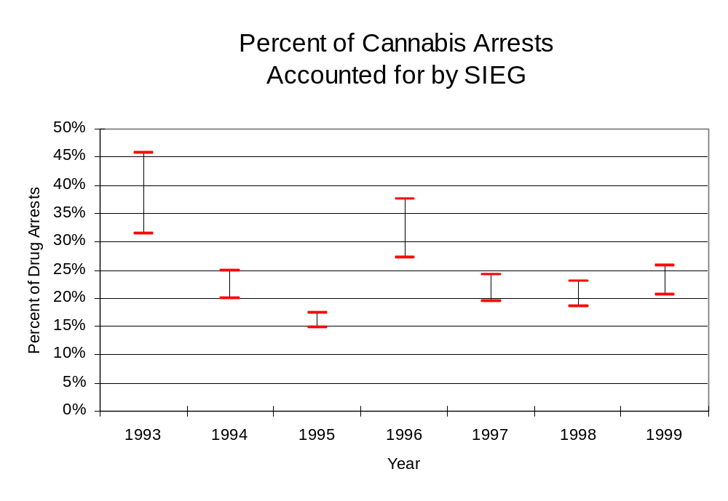
Figure 11
Source: ICJIA calculations using
Illinois State Police and SIEG data
In Jackson, Union and Williamson counties the number of arrests for violations of Illinois’ Controlled Substances Act increased from 53 to 57 between 1993 and 1999. Between 1993 and 1999, the proportion of all drug arrests accounted for by violations of the Controlled Substances Act in the three-county region decreased from 27 percent to 21 percent. In 1999, SIEG reported 74 arrests for controlled substance violations, 60 percent of all drug arrests reported to the Authority by the unit.

Between 1993 and 1999, the arrest rate for controlled substances act violations for the region covered by SIEG increased slightly, from 38 to 40 arrests per 100,000 population (Figure 12). The controlled substances arrest rate in the participating agencies remained relatively stable, increasing only slightly, from 44 to 45 arrests per 100,000 population, while the arrest rate in the non-participating agencies more than doubled, from eight to 21 arrests per 100,000 population. The controlled substances arrest rate for SIEG increased dramatically, from five to 64 arrests per 100,000 population (Figure 12). Thus, in three out of the last four years, the arrest rate for violations of the Controlled Substances Act achieved by SIEG was higher than that achieved by jurisdictions participating in SIEG.

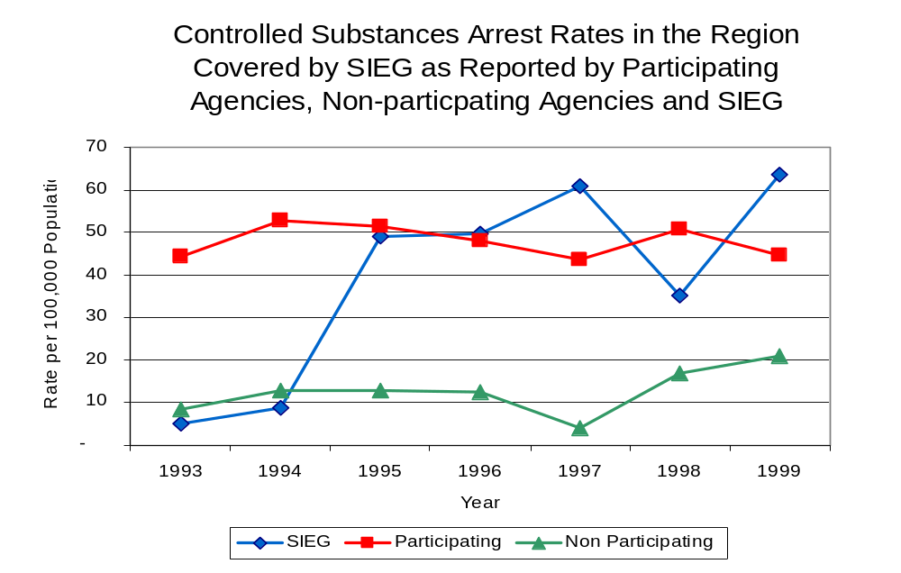
The data presented below represent the percent of total arrests for the violation of the Controlled Substances Act made by participating agencies that was accounted for by SIEG. An upper and lower bound is shown in Figure 13, which accounts for whether or not the units numbers are counted as part of the UCR submissions made by participating departments (which is unknown at this point). The upper bound indicates the percentage of arrests if all of the SIEG arrests are included in the local UCR submissions. The lower bound indicates the percentage if none of the SIEG arrests are included in the local UCR submissions.
Figure 12
Source: ICJIA calculations using
Illinois State Police and SIEG data

It is estimated that the proportion of all arrests for the violation of the Controlled Substances Act made in the jurisdictions of participating agencies, and accounted for by SIEG, was between 11 to 12 percent in 1993 and increased to between 59 to over 100 percent in 1999, thus accounting for a relatively large proportion of arrests for violation of the Controlled Substances Act. When examining the three figures together (Figure 9, 11 and 13), the data suggest that SIEG focused on arresting individuals violating the Controlled Substances Act, most of which are felony offenses.

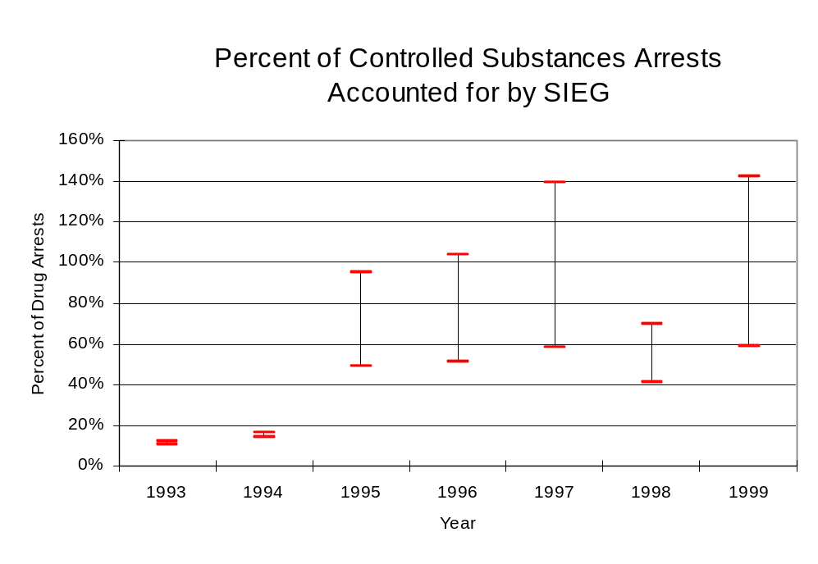
The majority of all drug arrests reported by SIEG are for delivery. Although the number of drug delivery arrests made by SIEG increased 38 percent between 1993 and 1999, from 58 to 80; drug delivery offenses accounted for decreasing proportions of arrests. Arrests for drug delivery accounted for 65 percent of all drug arrests made by SIEG between 1993 and 1999. When cannabis and controlled substance arrests were examined separately, the proportion of arrests for delivery decreased for both controlled substances and cannabis arrests. Although arrests for delivery of controlled substances accounted for 78 percent of all arrests for violations of the Controlled Substance Act during the period analyzed, the proportion of decreased from 100 percent in 1993 to 68 percent in 1999. Similarly, arrests for the delivery of cannabis accounted for 60 percent of all arrests for violations of the Cannabis Act; however, in 1999, arrests for delivery of cannabis accounted for 60 percent of all cannabis arrests, compared to 88 percent in 1993.
Figure 13
Source: ICJIA calculations using Illinois
State Police and SIEG data
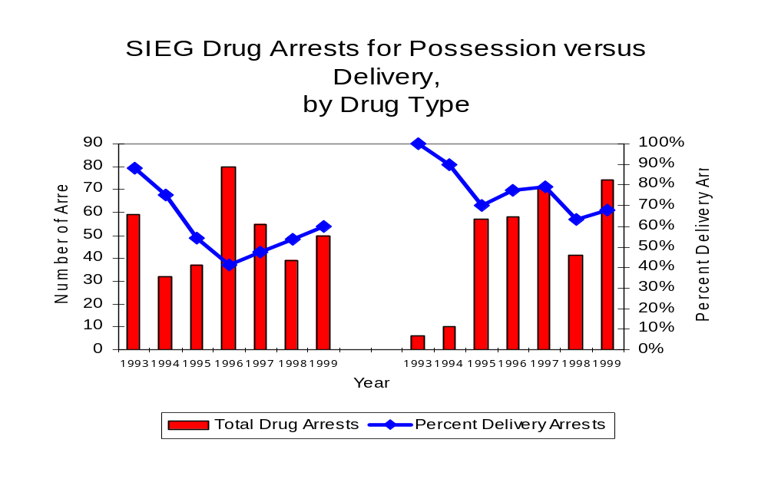
Cannabis Control Act
Controlled Substances Act
Figure 14
Source: ICJIA calculations using SIEG data

IV. Trends in Drug Seizures

Drugs seized by law enforcement agencies are another indicator of the extent and nature of illegal drug trade in a jurisdiction. When illegal drugs are seized by law enforcement agencies, all or a portion of the total amount seized is submitted to a crime lab for analysis. Most agencies submit drugs to one of the Illinois State Police crime labs. These labs record the quantity of drugs submitted from each county. This section discusses trends in the quantities of illegal drugs seized and submitted to the Illinois State Police from local law enforcement agencies in Jackson, Union and Williamson counties as well as the quantities of drugs seized by SIEG. It is important to note, however, that while SIEG data report the total quantities of drugs actually seized, local agency data only represent the quantities of seized drugs that are submitted to the Illinois State Police for analysis. County-level cannabis, cocaine and methamphetamine seizure rates for Illinois' 102 counties are provided in maps located in the Appendix of this report.

As in most Illinois jurisdictions, cannabis accounts for the majority of illegal drugs seized in the three-county region covered by SIEG. The quantity of cannabis seized and submitted by law enforcement agencies in Jackson, Union and Williamson counties dropped from more than 650,000 grams in 1993 to about 24,000 grams in 1999. Similarly, the quantity of cannabis seized by SIEG decreased during the same period, from more than 1.1 million grams in 1993 to about 329,000 grams in 1999 (Figure 15). Despite this large decrease, SIEG's cannabis seizure rate in 1999 of 282,403 grams per 100,000 population was much greater than the statewide cannabis seizure rate of 31,533 grams per 100,000 population, as well as the seizure rate of 16,717 grams per 100,000 population in the three-county region covered by SIEG (Map 2).
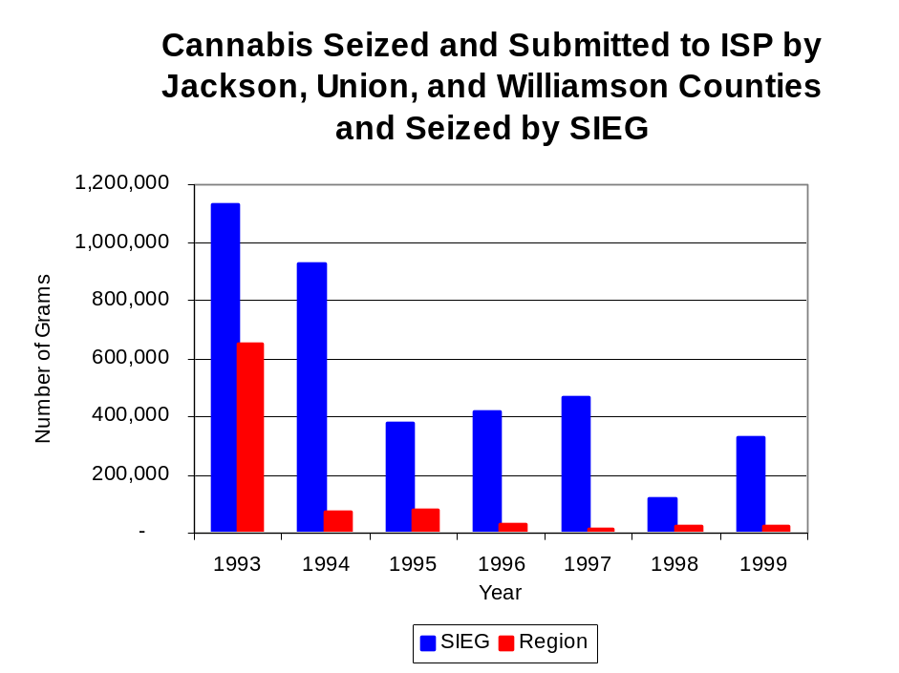
Figure 15
Source: ICJIA calculations using SIEG data

Between 1993 and 1999, a combination of crack and powder cocaine has accounted for a small proportion of drugs seized in the three-county region covered by SIEG. The quantity of cocaine seized and submitted by law enforcement agencies in Jackson, Union and Williamson counties decreased 45 percent, from 5,047 grams in 1993 to about 2,800 grams in 1999. Between 1993 and 1999, the quantity of cocaine seized by SIEG increased significantly, from about 50 grams to about 878 grams.

As a result, the proportion of all cocaine seized accounted for by powder cocaine remained varied between 1993 and 1999 in the three-county region covered by SIEG as it did for SIEG. For SIEG, although powder cocaine accounted for the largest proportion of total cocaine seizures in nearly every year examined, the proportion decreased from 100 percent in 1993 to 66 percent in 1999 (Figure 16). In 1999, the cocaine seizure rate in the three-county region covered by SIEG (1,974 grams per 100,000) was more than double SIEG’s cocaine seizure rate of 754 grams per 100,000 population, and dramatically lower than the statewide cocaine seizure rate of 15,735 grams per 100,000 population (Map 3).
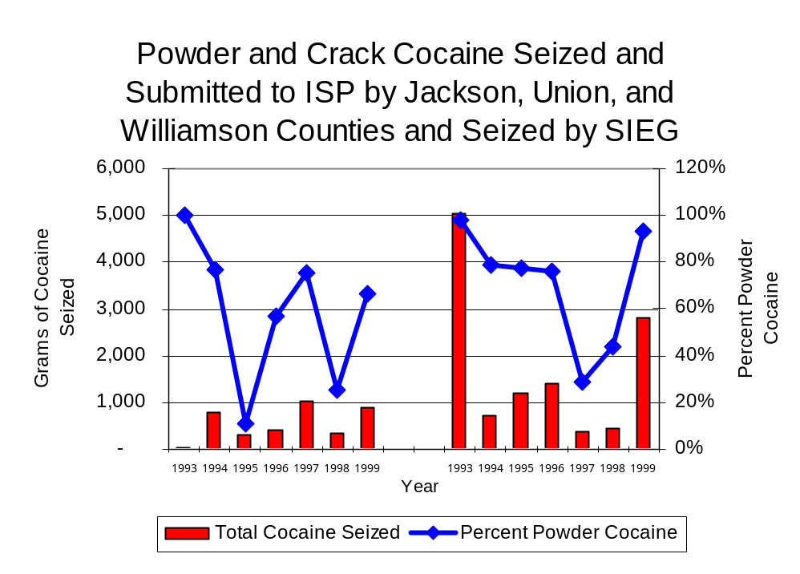
SIEG
Region
Figure 16
Source: ICJIA calculations using SIEG data

The total quantity of illegal drugs seized and submitted by law enforcement agencies in Jackson, Union and Williamson counties decreased significantly between 1993 and 1999, from a high of 657,029 grams to 28,562 grams. The total quantity of illegal drugs seized by SIEG decreased 70 percent, from a little over 1.1 million grams in 1993 to 337,754 grams in 1999.

Between 1993 and 1997, SIEG reported no methamphetamine seizures; however, SIEG reported 16 grams of methamphetamine seized in 1998 and 99 grams seized in 1999. During this period, 2,144 grams of methamphetamine were seized in the three-county region covered by SIEG. In 1999, SIEG had a methamphetamine seizure rate of 85 grams per 100,000 population, 43 percent higher than the rate of 60 grams per 100,000 population in the three-county region, but 14 percent lower than the statewide seizure rate of 98 grams per 100,000 population in 1996 (Map 4).

Trends in Prosecutions for Drug Offenses and All Felonies

Although Illinois has one of the best court reporting systems in the country, the Administrative Office of the Illinois Court only collects information regarding the aggregate number of court filings. Currently, there are no statewide data available on court filings by offense type. The Administrative Office of the Illinois Courts reports data on felony criminal court cases. After screening a case and deciding it warrants further action, the state’s attorney must file formal charges in court. Felony cases can be punished by a probation term up to four years and incarceration for more than one year.

Between 1989 and 1999, the number of felony filings in the three-county region covered by SIEG increased 33 percent, from 937 to 1,249 (Figure 17).

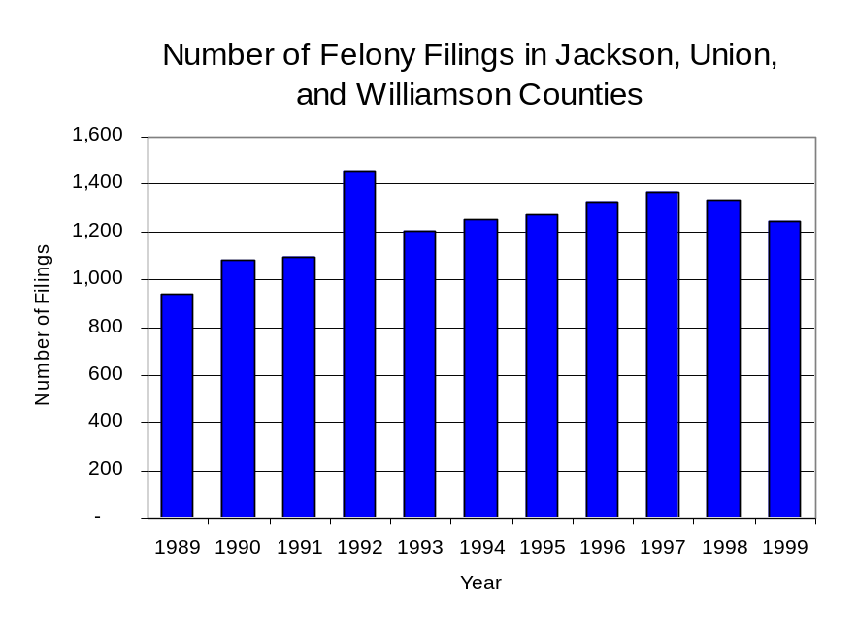
Figure 17
Source: Administrative Office of the Illinois Courts

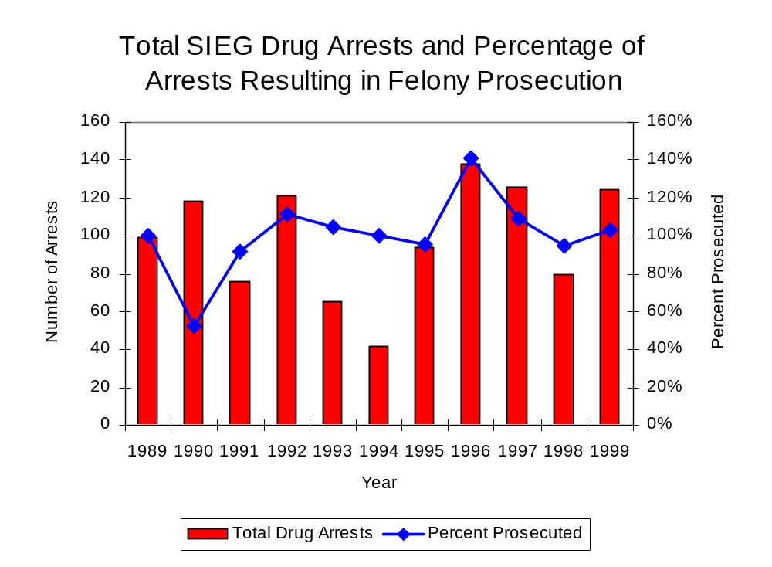
Between 1989 and 1999, there were a total of 1,103 drug prosecutions initiated as a result of SIEG arrests in Jackson, Union and Williamson counties. During this time, the number of SIEG drug arrests increased 29 percent, from 99 arrests in 1989 to 124 arrests in 1999 (Figure 18). Forty-nine percent of SIEG drug offender prosecutions during this period were for violations of the Controlled Substance Act. In some years, the proportion of arrests resulting in a prosecution exceeded 100 percent. This may be due to some differences in the timing of an arrest and the filings of charges, or could be due to the number of charges, rather than the number of defendants being reported by the unit. In addition, some offenders have charges filed, and a subsequent warrant issued, without an arrest taking place, which could also affect the number of prosecutions reported.
Figure 18
Source: SIEG

Between 1989 and 1999, nearly 100 percent (1,100) of the 1,103 drug offenders who were prosecuted as a result of SIEG activity were convicted. Convictions for controlled substances accounted for 49 percent of all SIEG initiated convictions during the period analyzed.

VI. Trends in Percent of Convicted Drug Offenders Sentenced to Prison

Anyone convicted of a felony in Illinois can be sentenced either to prison or probation, or receive conditional discharge. A number of factors influence the type and length of sentence imposed on convicted felons, including the severity of the crime, the offender’s criminal and social history, safety of the community and legislation affecting certain types of offenses. For some types of convictions, a sentence to prison is required by state statute.

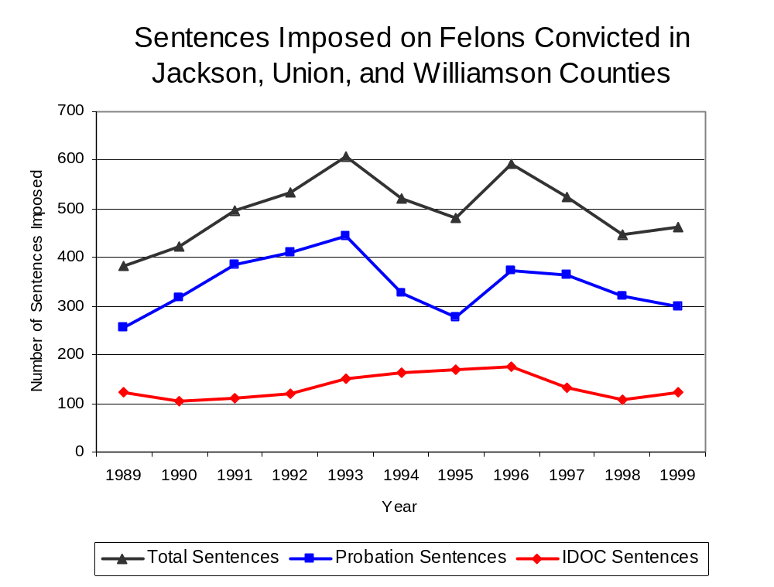
Between 1989 and 1999, the number of offenders convicted of a felony and sentenced in the three-county region covered by SIEG increased 21 percent, from 382 to 461. The number of convicted felons sentenced to the Illinois Department of Corrections (IDOC) increased slightly between 1989 and 1999, from 122 to 123, with a high of 176 in 1996. However, the proportion of felons sentenced to IDOC decreased from 32 percent in 1989 to 27 percent in 1999. In 1999, 300 probation sentences were imposed on convicted felons, 17 percent more than the number of probation sentences in 1989 (257) (Figure 19). The proportion of felons sentenced to probation decreased slightly during the period analyzed, from 67 in 1989 to 65 percent in 1999. Sentences other than prison or probation account for the remaining 8 percent of felony sentences imposed in 1999.
Figure 19
Source: Administrative Office of the Illinois Courts

Between 1989 and 1999, the number of SIEG drug offenders convicted and sentenced increased from 61 to 71. During the period analyzed, the number of convicted SIEG drug offenders sentenced to probation increased from 36 in 1989 to 56 in 1999, although in 1993, the number of convicted SIEG drug offenders sentenced to probation reached a period high of 93. Conversely, the number of convicted SIEG drug offenders sentenced to jail decreased from ten to zero. The number of drug offenders sentenced to prison remained unchanged at 15 between 1989 and 1999, with a period high of 71 sentenced to prison in 1996 (Figure 20). In 1999, among those SIEG drug offenders convicted and sentenced, probation sentences accounted for the largest proportion (79 percent), followed by prison sentences (21 percent). There were no SIEG drug offenders sentenced to jail in 1999.
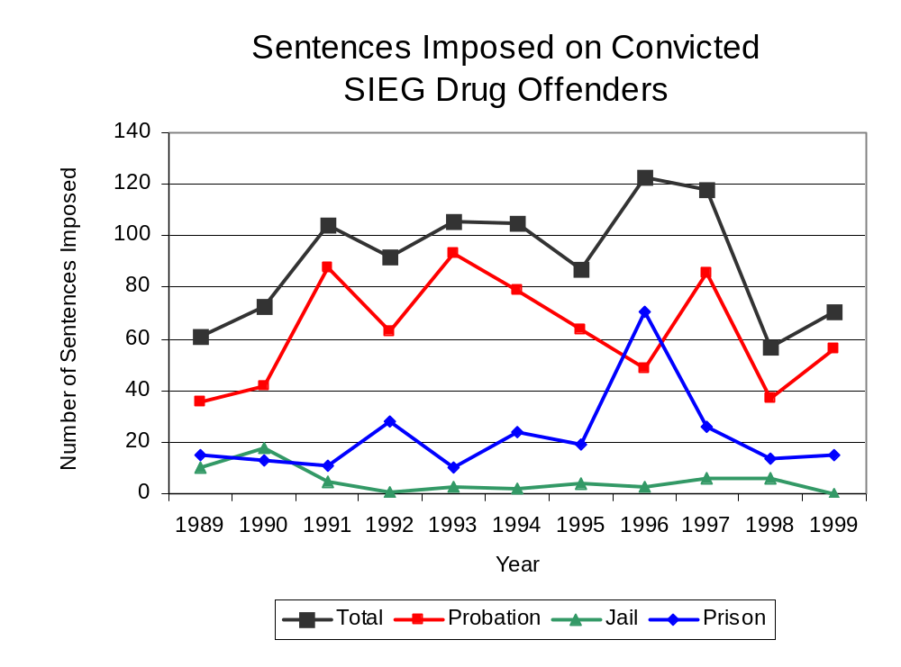
Figure 20
Source: SIEG

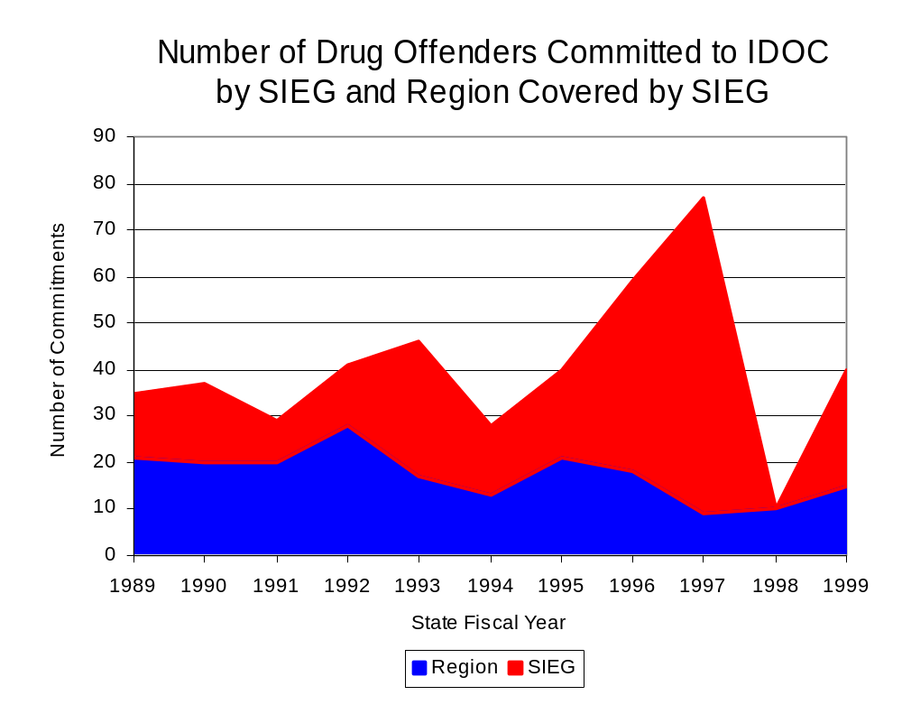
Between state fiscal years 1989 and 1999, the number of new court commitments to IDOC’s Adult Division for drug offenses from the three-county region covered by SIEG decreased from 21 to 15, while the number of drug offender admissions by SIEG increased from 14 to 25 between 1989 and 1999 (Figure 21). Thus, during the period analyzed, prison sentences resulting from SIEG cases far exceeded the number of drug-law violators sent to prison from the region where SIEG operates. This discrepancy may be due to the fact that some offenders sentenced to prison resulting from SIEG cases may have been sentenced for multiple charges, and each charge was reported to the Authority, whereas the data provided for by IDOC represent only the most serious charge for which offenders were sentenced.
Figure 21
Source: Illinois Department of Corrections

During the period analyzed, drug offenders accounted for a decreasing proportion of adults convicted and sentenced to prison from Jackson, Union and Williamson counties. In 1989, drug offenses accounted for 18 percent of all commitments to IDOC, compared to 12 percent in 1999 (Figure 22).
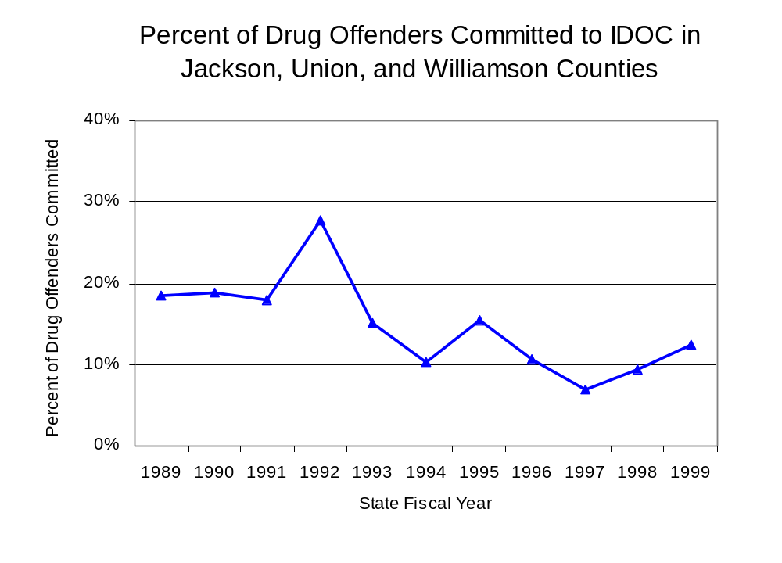
Figure 22
Source: Illinois Department of Corrections

Penalties for drug offenses were also examined between 1993 and 1999. Class 4 felonies accounted for the largest proportion (43 percent) of sentences to IDOC for drug offenses, followed by Class 2 felonies (23 percent), Class 3 and Class 1 felonies (17 percent and 12 percent, respectively). Class X felonies accounted for the smallest proportion of sentences to IDOC (6 percent). Between 1993 and 1999, the number of Class 1 felony sentences increased from zero to 3, Class 3 felony sentences increased from one to three, and Class 4 felony sentences increased from four to eight. Class 2 felony sentences decreased from seven to zero, as did the number of Class X felonies, which decreased from two to one (Figure 23). Overall, the number sentenced under each classification varied between 1993 and 1999.

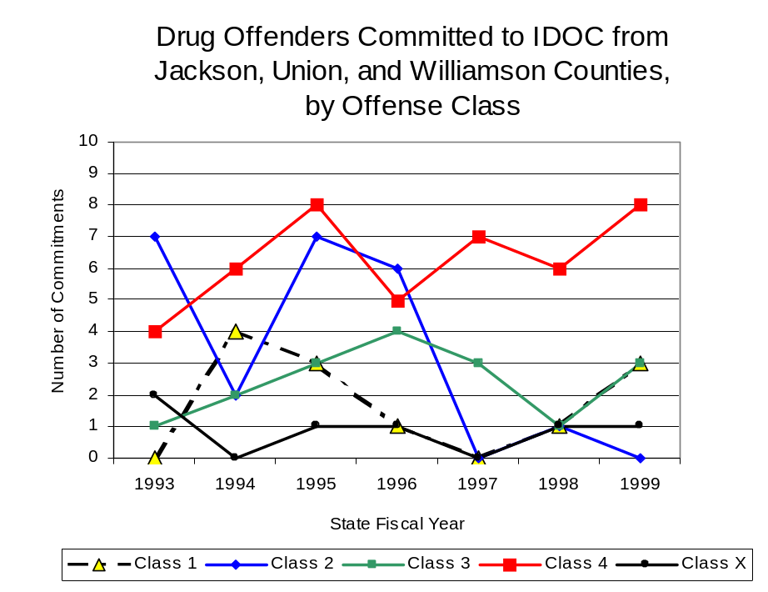
The mean sentence length for Class 2 felonies decreased from 3.43 years to 0 between 1993 and 1999. The mean sentence length for Class 4 felonies decreased from 3.13 to 2.5 years during the period. The mean sentence length for Class X felonies more than tripled, from 6.5 to 20 years, while Class 1 felony sentences increased from 0 to 6 between 1993 and 1999. The mean sentence for a Class 3 felony remained unchanged at 3 years during the period analyzed.
Figure 23
Source: Illinois Department of Corrections

VII. Trends in Drug Treatment Admissions in SIEG Region by Drug Type

In addition to considering indicators of the extent and nature of drug abuse as reported through the criminal justice system (for example, arrests and prison sentences), there are indicators of substance abuse available from other Illinois social service agencies. Overseeing and supporting treatment for substance users, whether they are referred from the criminal justice system or elsewhere, is the responsibility of the Illinois Department of Human Services’ Office of Alcoholism and Substance Abuse (OASA). It is important to note, however, that while OASA data represent the majority of the overall demand for substance abuse treatment in the state, some private programs provide treatment services to a smaller but significant number of clients who may not be included in the state’s reporting system.

In state fiscal year 1999, OASA reported 1,943 admissions for alcohol or drug abuse treatment from Jackson, Union and Williamson counties, 52 percent more than the 1,279 admissions in 1989 (Figure 24). Among the 1,943 admissions to substance abuse treatment in state fiscal year 1999, 61 percent (1,193) reported alcohol as their primary substance of abuse, while abuse of illicit substances accounted for 36 percent (695 admissions). Two percent reported no primary substance of abuse.
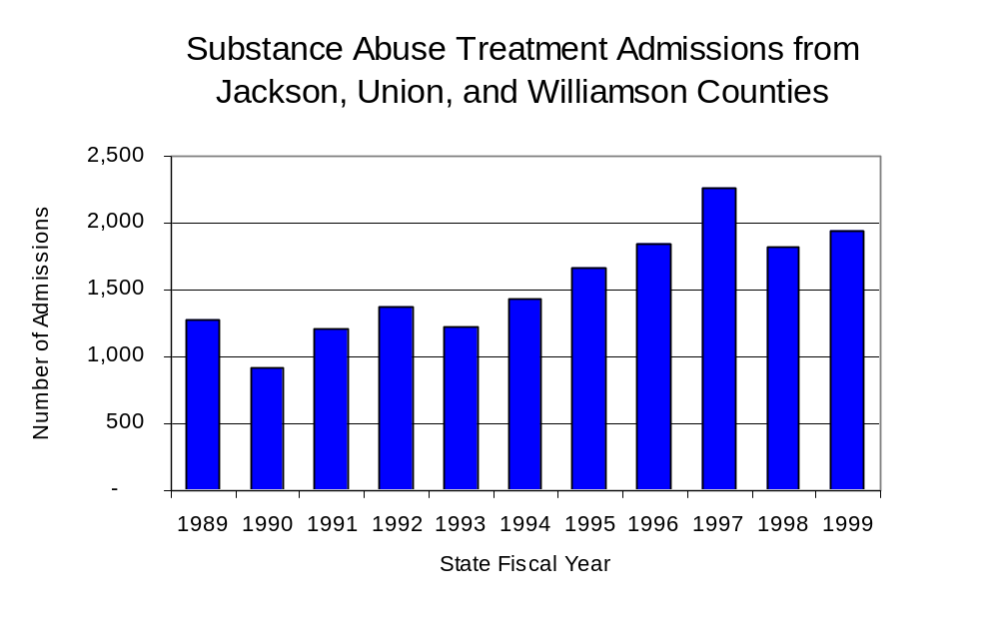
Figure 24
Source: Illinois Department of Human Services’
Office of Alcoholism and Substance Abuse

While drug treatment admissions can be considered a measure of the demand placed on a specific component of the human services system within Illinois, the extent and nature of drug treatment admissions could also be indicative of the substance abuse problem within a particular region. In some respects, the characteristics of those admitted to drug treatment can be considered a profile of the most serious drug abusers in the community, since admission to treatment requires a documented, formal assessment of a drug problem and a level of substance abuse warranting treatment. By comparing the types of drugs of abuse reported by those admitted to substance abuse treatment with the types of drugs involved in law enforcement agency arrests, one can get a sense of the degree to which arrests reflect the drugs which are most problematic within a community.

In the following analyses, the percent of arrests accounted for by drugs classified under Illinois’ Controlled Substances Act (primarily cocaine, heroin, and methamphetamine) versus the Cannabis Control Act (marijuana) across the participating agencies combined, non-participating agencies combined and SIEG are compared to the proportion of drug treatment admissions accounted for by these groups of substances. From these comparisons, a number of general conclusions can be made. First, the proportion of arrests made by SIEG accounted for by drugs other than marijuana (Controlled Substances Act offenses) was close to the proportion of drug treatment admissions from the covered region accounted for by these substances. Thus, there is considerable convergence between the drugs involved in SIEG arrests and treatment admissions. On the other hand, the majority of arrests by local police departments (including those participating in SIEG and non-participating agencies) were for cannabis offenses. Thus, while local arrests may reflect the most widely available and used drug in the region, they did not tend to involve the substances considered to be most serious (i.e., felony versus misdemeanor) nor the substances for which individuals were seeking and receiving treatment (Figure 25).

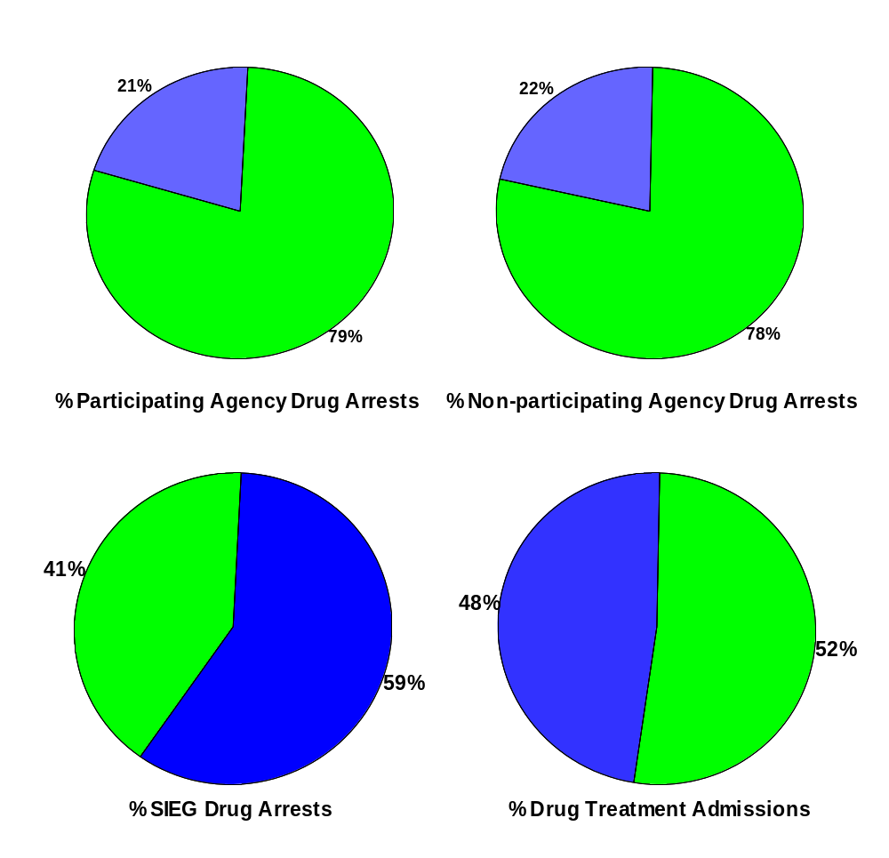
CannabisControlled Substances
Comparison of Drug Arrests by SIEG and Participating and Non-participating Agencies vs. Drug Abuse Treatment Admissions in Jackson, Union, and Williamson Counties, 1999
Source: Illinois Department of Human Service's Office of Alcoholism and Substance Abuse and SIEG
Figure 25

VIII. Trends in Drug Exposed Births

Illinois continues to experience the effects of prenatal substance abuse. In Illinois, if a baby is born and thought to have been exposed to illegal substances or alcohol, either through observation by physicians or toxicology tests, the case is reported to the Illinois Department of Children and Family Services. These cases are then investigated by DCFS to verify the child’s prenatal exposure to either alcohol or illegal substances. Between state fiscal years 1989 and 1999, nearly one-half (50) of Illinois’ 102 counties reported at least one case of a substance-affected infant.

Between state fiscal years 1989 and 1999, the number of drug-exposed infant cases reported in the three-county region covered by SIEG increased from three to seven. Between state fiscal years 1989 and 1999, 15 cases, or 36 percent of all cases reported, were verified as involving prenatal drug use by a DCFS investigation. Following a trend similar to that of reported cases, verified cases of drug-exposed infants in the SIEG region increased between 1989 and 1999 from zero to five. (Figure 26).
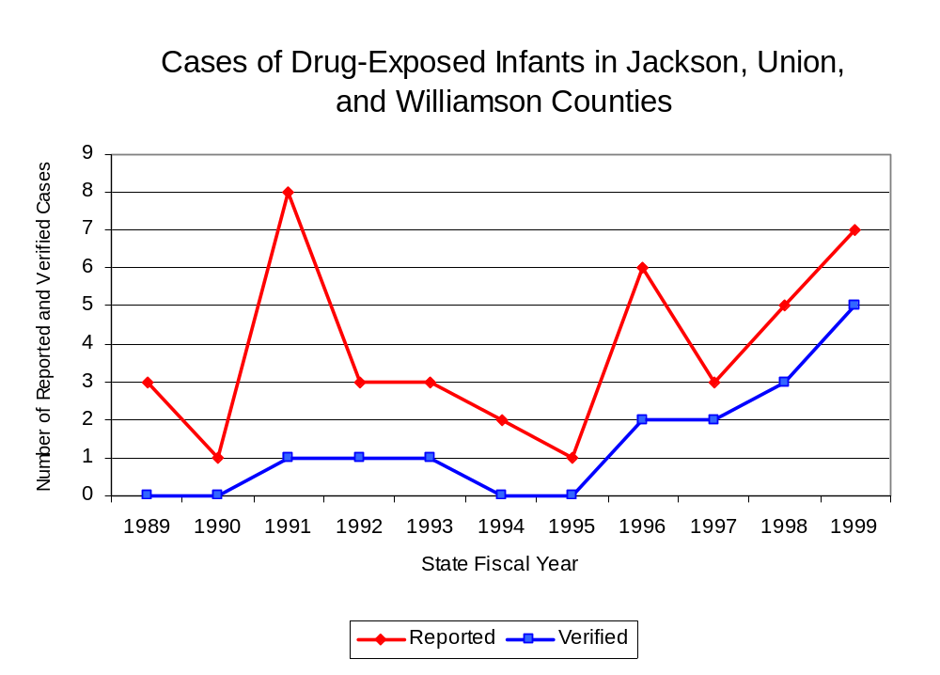
Source: Department of Children and Family Services
Figure 26

IX. Summary of Drug Situation

Although the distribution of illegal drugs is difficult to measure precisely, data obtained from criminal justice sources can be helpful in estimating drug availability. Information from a recent survey of Illinois drug enforcement units, as well as the most up-to-date data available on drug price, are presented as indicators of the drug supply in Illinois.

In 1995, 1996 and 1998, the Authority conducted a survey of each MEG and task force in Illinois to gauge the perceived availability of drugs in the areas they cover. Questions were asked concerning the availability of specific drugs, and results were analyzed by region of the state. MEGs and task forces are classified as being either urban, rural or mixed urban/rural based upon the classification of the county(s) that each unit covers, and, for purposes of this report, are compared to the average of similar units.

According the SIEG survey responses, cannabis continued to be the most visible drug on the street and was reported to be “readily available” across all regions analyzed. While perceived availability of cannabis, PCP, and methamphetamine remained relatively unchanged in the three-county region covered by SIEG, the perceived availability of crack, heroin, LSD and cocaine decreased slightly since the 1996 survey. Methamphetamine was reported as “readily available” in the region covered by SIEG in 1998. The same drug was reported as “moderately available” in Illinois and available to a higher extent (than Illinois) by all MEGs and task forces in the mostly rural regions. The perceived availability of cocaine and crack tended to be greater across Illinois and in other mostly rural regions than in the region covered by SIEG, while the perceived availability of PCP, methamphetamine and LSD was greater in the region covered by SIEG.
(Figure 27).
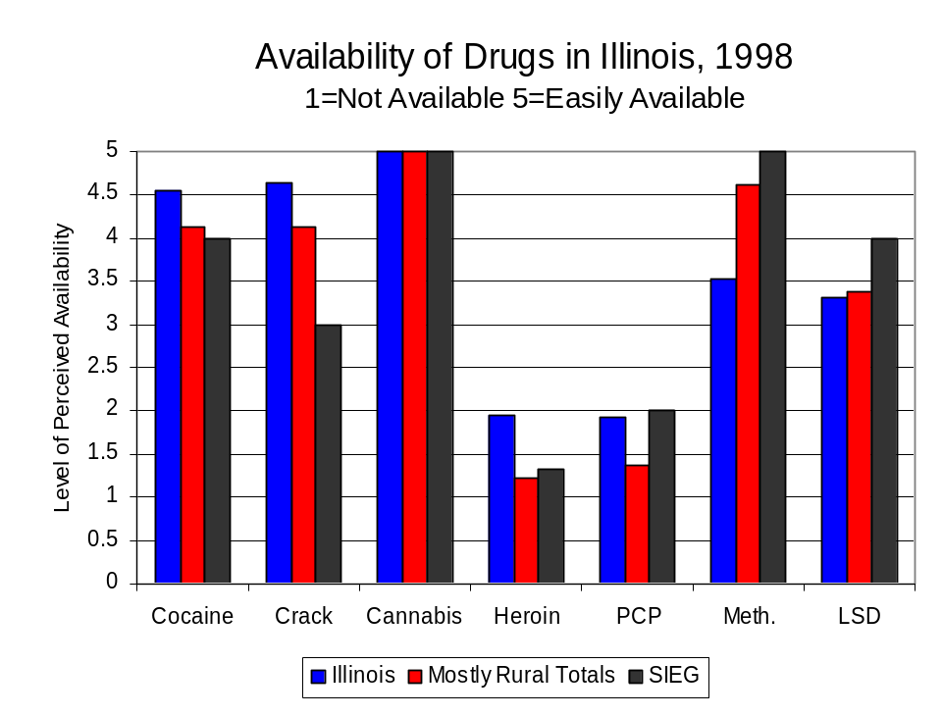
Figure 27
Source: Authority Survey of Illinois MEGs and task forces
Another market indicator that can be used to assess availability is drug price. Lower prices tend to suggest a sufficient supply to meet demand, while increasing prices indicate decreased availability.

Based on a statewide survey of MEG and task force units, the average price of cocaine, crack and methamphetamine appear to be relatively stable across all regions surveyed in 1998, while prices for PCP and heroin appear to vary somewhat across Illinois. The average price of cocaine in the region covered by SIEG remained the same between 1996 and 1998, while it increased for MEGs and task forces in the mostly rural regions and across Illinois. The 1998 average price of cocaine reported by SIEG was $100 per gram, compared to $98 per gram across Illinois and all MEGs and task forces in other mostly rural regions (Figure 28). The average price of crack in the region covered by SIEG was reported as $100 per gram, lower than the price of $102 per gram across Illinois and the price of $109 per gram reported across all other MEGs and task forces in mostly rural regions. In 1998, the average price of methamphetamine was reported as approximately $100 per gram in the SIEG region, $96 per gram across Illinois and $94 per gram across all MEGs and task forces in the mostly rural regions. The price of heroin was reported as $88 per gram across all MEGs and task forces in the mostly rural regions, and as $165 per gram across Illinois. SIEG reported no numbers in 1998 for the price of cannabis, heroin, and PCP.

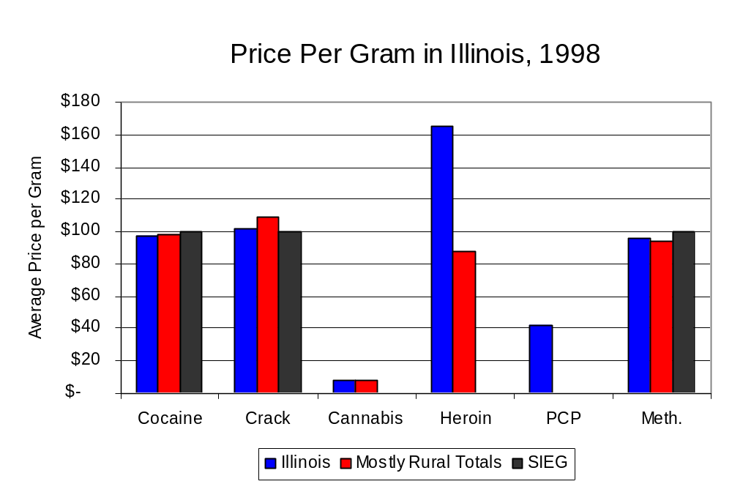
Figure 28
Source: Authority Survey of Illinois MEGs and task forces

X. Appendices
1999 Percent of Illinois'
County-level Population Covered by an Authority-funded Multi-jurisdictional Enforcement Group or Task Force
Map 1
* Shaded counties indicate that at least one law enforcement agency within the county participates in a MEG or task force
Percent of County Population Covered by MEG or Task Force

1999 Illinois
Cannabis
Seizure Rates, by County
Map 2
Cannabis Seizure Rate
(rate per 100,000 population)
1999 Illinois
Cocaine
Seizure Rates, by County
Map 3
Cocaine Seizure Rate
(rate per 100,000 population)
1999 Illinois Methamphetamine
Seizure Rates, by County
Map 4
Methamphetamine Seizure Rate
(rate per 100,000 population)

Bibliography

Administrative Office of the Illinois Courts, Annual Report to the Supreme Court of Illinois.
1989 through 1999 reports, Springfield, Illinois.

Administrative Office of the Illinois Courts’ Probation Division, Statewide Probation Data
Report. 1989 through 1999 reports, Springfield, Illinois.

Illinois Department of Human Services’ Office of Alcoholism and Substance Abuse. Data
provided for state fiscal years 1989 through 1999, Springfield, Illinois.

Illinois Department of Children and Family Services, Child Abuse/Neglect Statistics Report,
1989 through 1999 reports, Springfield, Illinois.

Illinois Department of Corrections. Data provided for fiscal years 1989 through 1999,
Springfield, Illinois.

Illinois State Police, Crime in Illinois. 1993 through 1999 reports, Springfield, Illinois.

Illinois State Police, Drug Statistics Report. Monthly reports, January 1989 through
December 1999, Springfield, Illinois.

Southern Illinois Enforcement Group. Monthly reports, January 1989 through December
1999, Carbondale, Illinois.

U.S. Bureau of the Census.


George H. Ryan, Governor
Peter B. Bensinger, Chairman
Candice M. Kane, Executive Director

